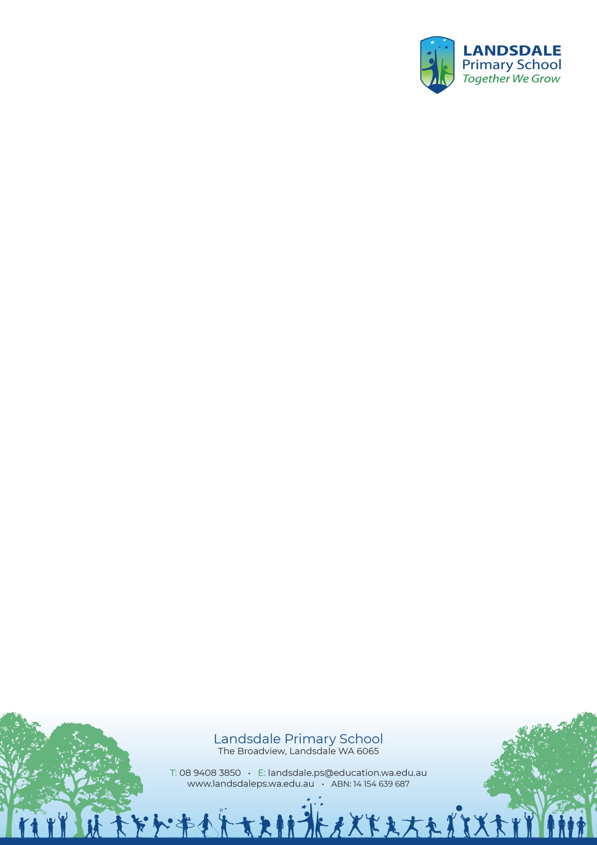
* Staff meetings include 5 mandated hours and 3 trade-off hours (as indicated)
* Please refer to the Whole School Assessment Schedule for Landsdale PS Whole School Assessments.

TERM 4 PLANNER 2026
 | Monday | Tuesday | Wednesday | Thursday | Friday
1 | Oct 12  Term 4 Starts  WA Bike Month  PBS Learners: We will be on time after breaks to begin learning. | Oct 13  WA Bike Month | Oct 14  WA Bike Month  Kindy B | Oct 15  WA Bike Month | Oct 16  WA Bike Month  LA16 Assembly  Interschool Cross Country  P&C Disco
2 | Oct 19  WA Bike Month  PBS Learners: We keep trying when something is challenging | Oct 20  WA Bike Month | Oct 21  WA Bike Month  Kindy A  Kindy library session | Oct 22  WA Bike Month  School Disco (TBC) | Oct 23  WA Bike Month  School Development Day
3 | Oct 26  WA Bike Month  Book Fair | Oct 27  WA Bike Month  Book Fair | Oct 28  WA Bike Month  Book Fair  Kindy B  Graduation Photos  Kindy Pop in and play | Oct 29  WA Bike Month  Book Fair | Oct 30  WA Bike Month  Book Fair  World Teachers Day Thankyou morning tea  LA15 Assembly
4 | Nov 2  PBS Kind: We play fairly by sharing, taking turns and being honest | Nov 3  2027 Minister Elections  P&C Meeting | Nov 4  Yr 6 Camp  Kindy A  Kindy Pop in and play | Nov 5  Yr 6 Camp | Nov 6  Yr 6 Camp  Canteen Day
5 | Nov 9  Yr 1-4 Swimming Lessons | Nov 10 | Nov 11  Remembrance Day  Kindy B  Kindy Pop in and play | Nov 12  Parent/Volunteer Thankyou Morning Tea | Nov 13  World Diabetes Day  (wear blue)  LA04 Assembly
6 | Nov 16  PBS Safe: We wear our hat to play  Yr 1-4 Swimming Lessons | Nov 17 | Nov 18  Kindy Pop in and play  Kindy A | Nov 19  Year 5 Wellness Day (TBC) | Nov 20  Reporting to Parents/Families Day
7 | Nov 23  Beach Swimming Yr 5-6 | Nov 24 | Nov 25  Kindy parent info session  Kindy B | Nov 26  World Sustainable Transport Day | Nov 27
8 | Nov 30  Completion of device history checks  Beach Swimming Yr 5-6 | Dec 1  P&C Meeting | Dec 2  Kindy A | Dec 3  International Day of People with Disability | Dec 4  Year 6 Transition
9 | Dec 7  Book Awards K-2  PBS Responsible: We put our rubbish in the bin | Dec 8  Book Awards 3-6 | Dec 9  Kindy B  Staff Farewells  New Staff Inductions | Dec 10 | Dec 11  End of Year concert 1pm
10 | Dec 14  Staff Farewells | Dec 15  Yr 6 Graduation Practice 12:40-3:30pm | Dec 16  Yr 6 Graduation  Kindy A  Reports emailed home | Dec 17  Term 4 Ends  Christmas Dress Up | Dec 18  School Development Day

